Universidade do Algarve
  - Faculdade de Ciências e Tecnologia
  - Licenciatura em Engenharia Informática

Redes de Computadores I

Laboratório 1
Introdução ao Wireshark

Realizado por: Diogo Carvalho nº 90247
PL: 2
Docente: Rui Filipe Rosa Paulo
Ano Letivo: 2025/2026

Relatório

1. List 3 different protocols that appear in the protocol column in the unfiltered
packet-listing window in step 7 above.

Resposta

TCP, ICMP e TLSv1.3

2. How long did it take from when the HTTP GET message was sent until the HTTP OK reply was received? (By default, the value of the Time column in the packetlisting window is the amount of time, in seconds, since Wireshark tracing began.
To display the Time field in time-of-day format, select the Wireshark View pull down menu, then select Time Display Format, then select Time-of-day.)

Resposta

GET teve time: 3.821957
HTTP/1.1 200 OK teve time: 3.942800

Logo 3.942800 − 3.821957 = 0.120843 s

Demorou 0.120843 s

3. What is the Internet address of the gaia.cs.umass.edu (also known as wwwnet.
cs.umass.edu)? What is the Internet address of your computer?

Resposta

gaia.cs.umass.edu: 128.119.245.12
Meu Computador: 192.168.1.67

4. Print the two HTTP messages (GET and OK) referred to in question 2 above. To
do so, select Print from the Wireshark File command menu, and select the
“Selected Packet Only” and “Print as displayed” radial buttons, and then click
OK.

Resposta

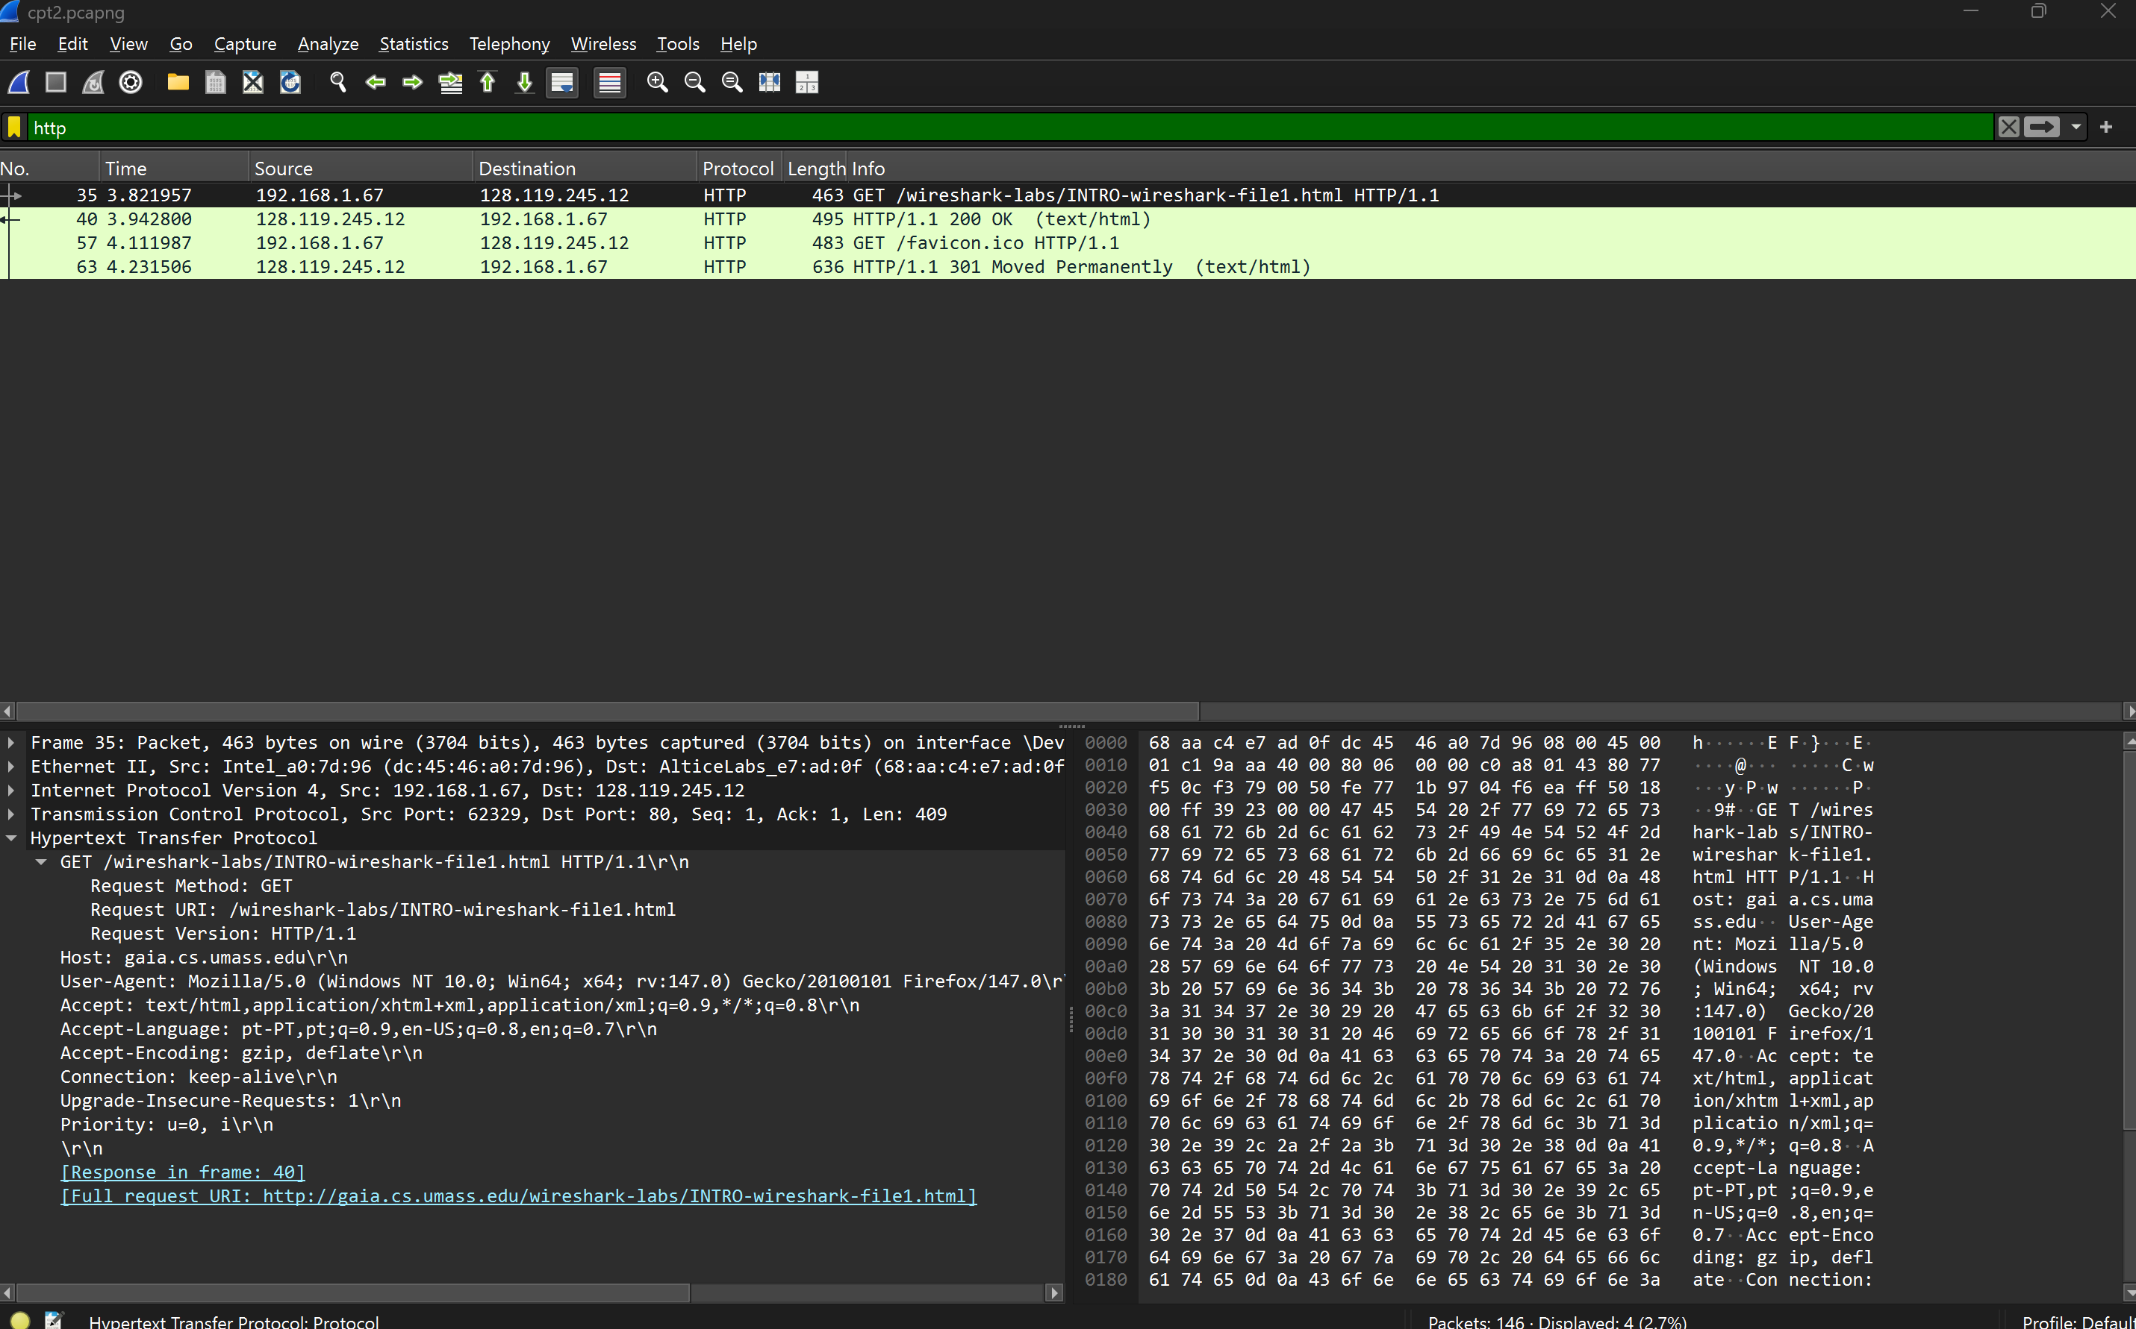
GET
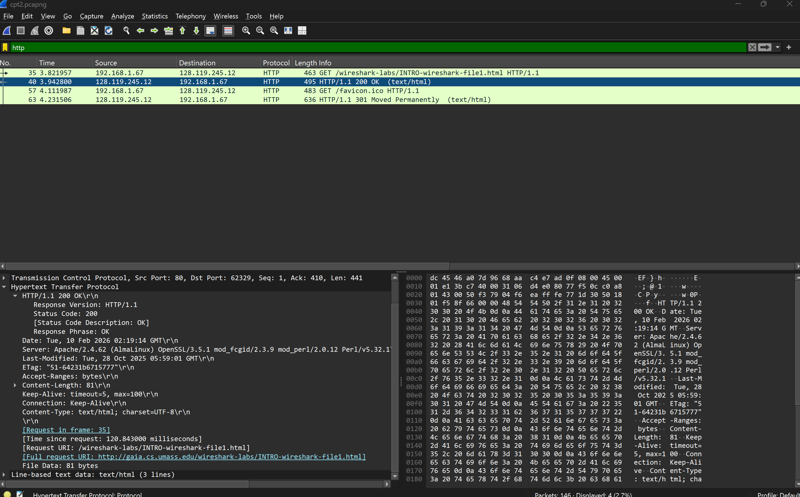
OK

